World Suicide Prevention Day
September 10, 2016.
We Hope- “ Be Successful ”
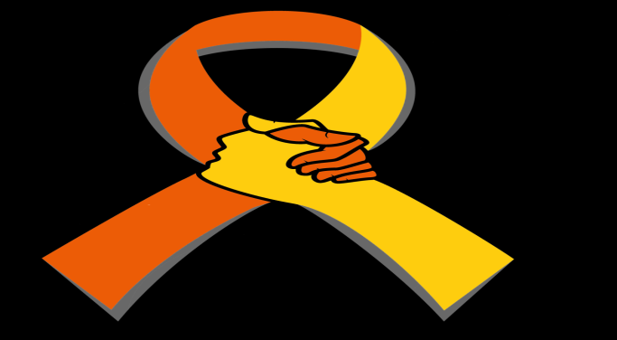
Arranged By- Our Social Organization

Each and Every – “Light a Candle Near A Window”


